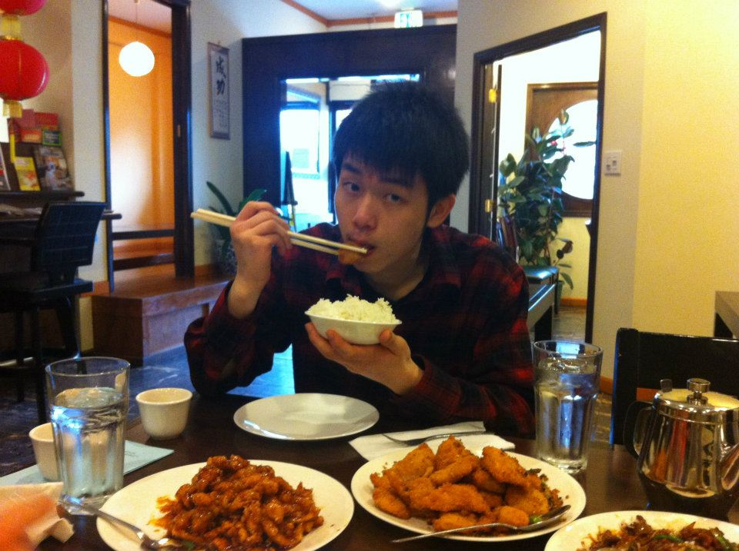

Name: Chun-Wei Chen (Michael)

Email address: mijc_517@yahoo.com.tw

Year: 3

Hometown: Taiwan

I went to Los Angeles and San Diego with my family during the winter break.